To successfully build **StructuralConnectionsSamples.sln** open **StructuralConnectionsSDKSamples.Common.props** in any text editor and edit **ASInstallDir** property with the corresponding path for Revit installation (e.g. C:\Program Files\Autodesk\Revit 2025\AddIns\SteelConnections)

**Joint config xml**

1. Create a folder named ThirdPartySettings under the C:\ProgramData\Autodesk\Revit Steel Connections 2025 \en-US\
2. Under the ThirdPartySettings folder create an .xml with the following contents (check SteelConnectionsSampleJoints.xml provided with the samples):

<?xml version="1.0" encoding="utf-8"?>

<PaletteData Version="2.0" xmlns:xsi="http://www.w3.org/2001/XMLSchema-instance" xmlns:xsd="http://www.w3.org/2001/XMLSchema">

<ResourceDll>SteelConnectionsDotNetJointExample.dll</ResourceDll>

<PreviewResourceDll>SteelConnectionsDotNetJointExample.dll</PreviewResourceDll>

<Categories>

<PaletteCategory>

<Name>Plates at beam</Name>

<Image>ResDummy.png</Image>

<Items>

<PaletteItem>

<Description>Steel Connections Sample Joint</Description>

<Command>SteelConnectionsJointExample</Command>

<PreviewText>This is my test joint</PreviewText>

<Images>

<string>Dummy.png</string>

</Images>

<PreviewImages>

<string>ResDummy.png</string>

</PreviewImages>

<TypeId>E8BB9834-E1A2-4644-9C59-1C9812C04E8E</TypeId>

</PaletteItem>

</Items>

</PaletteCategory>

<PaletteCategory>

<Name>Net joint</Name>

<Image>ResDummy.png</Image>

<Items>

<PaletteItem>

<Description>Bridge Girder DotNet Example</Description>

<Command>BridgeGirderSample</Command>

<PreviewText>This is my test joint 2</PreviewText>

<Images>

<string>Dummy.png</string>

</Images>

<PreviewImages>

<string>ResDummy.png</string>

</PreviewImages>

<TypeId>36c78249-132f-4037-9822-3802a5cf9345</TypeId>

</PaletteItem>

</Items>

</PaletteCategory>

<PaletteCategory>

<Name>Net joint</Name>

<Image>ResDummy.png</Image>

<Items>

<PaletteItem>

<Description>Lap Joint Example</Description>

<Command>LapJoint</Command>

<PreviewText>This is my Lap joint</PreviewText>

<Images>

<string>Dummy.png</string>

</Images>

<PreviewImages>

<string>ResDummy.png</string>

</PreviewImages>

<TypeId>B2E820AB-A8BD-4998-878C-1BE4364B1BD9</TypeId>

</PaletteItem>

</Items>

</PaletteCategory>

<PaletteCategory>

<Name>Net joint clip angle</Name>

<Image>ResDummy.png</Image>

<Items>

<PaletteItem>

<Description>Steel Connections Clip Angle Example</Description>

<Command>SampleClipAngle</Command>

<PreviewText>This is my test joint 3</PreviewText>

<Images>

<string>Dummy.png</string>

</Images>

<PreviewImages>

<string>ResDummy.png</string>

</PreviewImages>

<TypeId>8B4FDDC8-946A-49B4-AF65-AC54C5615AB1</TypeId>

</PaletteItem>

</Items>

</PaletteCategory>

<PaletteCategory>

<Name>Native Sample Clip Angle</Name>

<Image>ResDummy.png</Image>

<Items>

<PaletteItem>

<Description>Steel Connections Native Clip Angle</Description>

<Command>SampleClipAngleNative</Command>

<PreviewText>C++ Native Clip Angle Example</PreviewText>

<Images>

<string>Dummy.png</string>

</Images>

<PreviewImages>

<string>ResDummy.png</string>

</PreviewImages>

<TypeId>FD62E6AB-0412-4F2B-9DB8-C5D5385F8042</TypeId>

</PaletteItem>

</Items>

</PaletteCategory>

</Categories>

</PaletteData>

Note: To ensure user assistance, it is important to mention that the required information for the upcoming samples:

* SampleClipAngle,
* SampleClipAngleNative,
* SampleLapJoint

has already been incorporated into AstorRules.RulesDllSigned and AstorRules.HRLDefinition.

AstorRules.RulesDllSigned

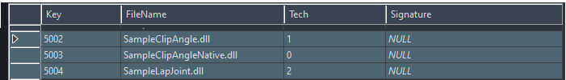

AstorRules.HRLDefinition



**SteelConnectionsJointExample**

1. Build the "SteelConnectionsJointExample" and "SampleDesign" projects.
2. Copy "SteelConnectionsJointExample.dll and "SampleDesign.dll" from "..\SDK\Samples\Binaries" to your local Revit installation under AddIns\SteelConnections subfolder (e.g." C:\Program Files\Autodesk\Revit 2025\AddIns\SteelConnections\”)
3. Add a record in the AstorRules.RulesDllSigned table for SteelConnectionsJointExample.dll

Key: an integer outside the standard Revit range (e.g.: 20000)

FileName: SteelConnectionsJointExample.dll

Tech: 1

1. Add a record in the AstorRules.HRLDefinition for SteelConnectionsJointExample.dll

Key: an integer outside the standard Revit range (e.g.: 20000)

RuleRunName: SteelConnectionsJointExample

InternalName: SteelConnectionsJointExample

Category: SteelConnectionsJointExample

Dll: - dll key set in step 3 (20000)

ClassId: {E8BB9834-E1A2-4644-9C59-1C9812C04E8E}

Version: 24



1. Run the script "dbo.RULE_CreatePlate.sql" inside AstorRules.mdf creating a table called "RULE_CreatePlate". (found under ..\Samples\Projects\SampleJoint)
2. Add a record in the table AstorJointsCalculation.NSAModuleDllSigned with the following values for each column:

Key: 12 (or an integer outside the standard Revit range - e.g.: 17000)

FileName: SampleDesign.dll

Tech: 1

1. Add a record in the table AstorJointsCalculation.NSAModule with the following values for each column:

Key: 59 (or an integer outside the standard Revit range - e.g.: 18000)

StressAnalysisCodeID: 1

JointInternalName: SteelConnectionsJointExample

NSAModuleInternalName: CreatePlateDesign_NSAModule

DefaultModule: 1

SortOrder: 1

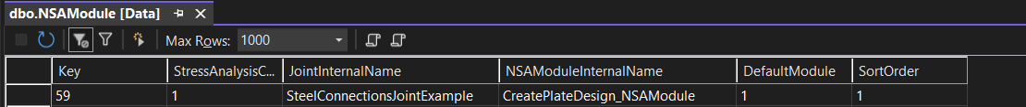

1. Add a record in the table AstorJointsCalculation.NSAModuleDefinition with the following values for each column:

Key: 59 (or an integer outside the standard Revit range - e.g.: 170000) make sure to use the same key from step (7).

ModuleRunName: SampleDesign

InternalName: CreatePlateDesign_NSAModule

NSAModuleDll: 12

ClassID: {C64ECF63-D01C-451F-B0E0-E3F85DFAC05E}

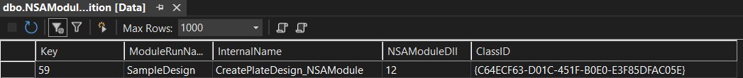

1. Open Revit and create a structural column (make sure the connection to the databases is closed after adding the values above, before starting Revit).
2. Open the connection Settings Dialog from the ‘Steel” tab and load the connection

1. Use the “Connection” button on the “Steel” tab to apply the connection on the column created at step 12.

**SteelConnectionsDotNetJointExample**

1. Build the project SteelConnectionsDotNetJointExample
2. Copy "SteelConnectionsDotNetJointExample.dll from "..\SDK\Samples\Binaries" to your local Revit installation under AddIns\SteelConnections subfolder (e.g." C:\Program Files\Autodesk\Revit 2025\AddIns\SteelConnections\”)
3. Add a record in the AstorRules.RulesDllSigned table for SteelConnectionsDotNetJointExample.dll

Key: an integer outside the standard Revit range (e.g.: 20001)

FileName: SteelConnectionsDotNetJointExample.dll

Tech: 2

1. Add a record in the AstorRules.HRLDefinition for SteelConnectionsDotNetJointExample.dll

Key: an integer outside the standard Revit range (e.g.: 170000)

RuleRunName: BridgeGirderSample

InternalName: BridgeGirderSample

Category: BridgeGirderSample

Dll: - dll key set in step 3

SubNameInDll: SteelConnectionsDotNetJointExample.BridgeGirderSample

ClassId: {36c78249-132f-4037-9822-3802a5cf9345}

Version: 24



5. Open Revit and create a structural beam (make sure the connection to the databases is closed after adding the values above, before starting Revit).

6. Open the connection Settings Dialog from the ‘Steel” tab “Add” the “Steel Connection Joint DotNet Example“ connection in the right pane.

8 .Use the “Connection” button on the “Steel” tab to apply the connection on the beam created at step 5.

**SampleClipAngle**

1.Build the project SampleClipAngle

2.Copy " SampleClipAngle.dll from "..\SDK\Samples\Binaries" to your local Revit installation under AddIns\SteelConnections subfolder (e.g." C:\Program Files\Autodesk\Revit 2025\AddIns\SteelConnections\”)

3.Add a record in the AstorRules.RulesDllSigned table for SampleClipAngle.dll

Key: an integer outside the standard Revit range (e.g.: 20002)

FileName: SampleClipAngle.dll

Tech: 1

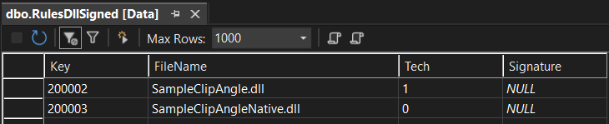

4. Add a record in the AstorRules.HRLDefinition for SampleClipAngle.dll

Key: an integer outside the standard Revit range (e.g.: 20002)

RuleRunName: SampleClipAngle

InternalName: SampleClipAngle

Category: SampleClipAngle

Dll: - dll key set in step rulesDLLSigned table

SubNameInDll: SampleClipAngle

ClassId: {8B4FDDC8-946A-49B4-AF65-AC54C5615AB1}

Version: 24



5. Open Revit and create a structural column, and a structural beam perpendicular on the column (make sure the connection to the databases is closed after adding the values above, before starting Revit).

6. Open the connection Settings Dialog from the ‘Steel” tab “Add” the “Steel Connections Clip Angle Example“ connection in the right pane.

7 .Use the “Connection” button on the “Steel” tab to apply the connection on the beam created at step 5.

**SampleClipAngleNative**

1.Build the project SampleClipAngleNative

2.Copy " SampleClipAngleNative.dll from "..\SDK\Samples\Binaries" to your local Revit installation under AddIns\SteelConnections subfolder (e.g." C:\Program Files\Autodesk\Revit 2025\AddIns\SteelConnections\”)

3.Add a record in the AstorRules.RulesDllSigned table for SampleClipAngleNative.dll

Key: an integer outside the standard Revit range (e.g.: 20003)

FileName: SampleClipAngleNative.dll

Tech: 0

4. Add a record in the AstorRules.HRLDefinition for SampleClipAngleNative.dll

Key: an integer outside the standard Revit range (e.g.: 20003)

RuleRunName: SampleClipAngleNative

InternalName: SampleClipAngleNative

Category: SampleClipAngleNative

Dll: - dll key set in step rulesDLLSigned table

SubNameInDll: SampleClipAngleNative

ClassId: {FD62E6AB-0412-4F2B-9DB8-C5D5385F8042}

Version: 24



5. Open Revit and create a structural column, and a structural beam perpendicular on the column (make sure the connection to the databases is closed after adding the values above, before starting Revit).

6. Open the connection Settings Dialog from the ‘Steel” tab “Add” the “Steel Connections Native Clip Angle “ connection in the right pane.

7 .Use the “Connection” button on the “Steel” tab to apply the connection on the beam created at step

**SampleLapJoint**

1. Build the project SampleLapJoint
2. Copy " SampleLapJoint.dll from "..\SDK\Samples\Binaries" to your local Revit installation under AddIns\SteelConnections subfolder (e.g." C:\Program Files\Autodesk\Revit 2025\AddIns\SteelConnections\”)
3. Add a record in the AstorRules.RulesDllSigned table for SampleLapJoint.dll

Key: an integer outside the standard Revit range (e.g.: 20001)

FileName: SampleLapJoint.dll

Tech: 2

1. Add a record in the AstorRules.HRLDefinition for SampleLapJoint.dll

Key: an integer outside the standard Revit range (e.g.: 170000)

RuleRunName: LapJoint

InternalName: LapJoint

Category: LapJoint

Dll: - dll key set in step 3

SubNameInDll: SampleLapJoint.LapJoint

ClassId: {B2E820AB-A8BD-4998-878C-1BE4364B1BD9}

Version: 24



5. Open Revit and create two structural flat beams (make sure the connection to the databases is closed after adding the values above, before starting Revit).

6. Open the connection Settings Dialog from the ‘Steel” tab “Add” the “Steel Connection Lap Joint“ connection in the right pane.

8 .Use the “Connection” button on the “Steel” tab to apply the connection on the beam created at step 5.